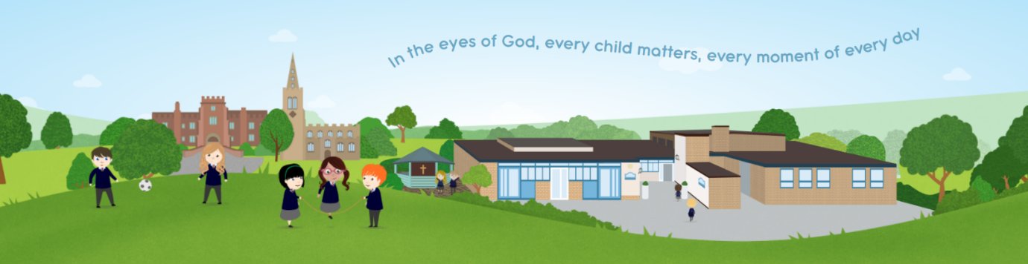

Buckden CE Primary Academy

Homework Policy

Approved on: | 01.02.2024
Next review date: | 01.02.2025

Vision

Every child is loved by God and is educated for wisdom, aspiration and global citizenship, to thrive in our community through a culture of dignity and respect. Their gifts, talents and wellness are cultivated with knowledge and skills to live life purposefully in all its fullness. In faith we ‘act’ ‘For nothing will be impossible with God’. Luke 1:37
Homework Policy

Our School Homework Policy promotes learning at home as an essential part of good education. Homework not only reinforces classroom learning, it also helps children to develop the skills and attitudes they need for successful lifelong learning.

Whilst we recognise that homework is an important component of the teaching and learning process, we also recognise that it is important for children to have time for play, leisure and physical activities outside of school.

The homework policy has been designed to sit alongside and compliment our bespoke Curriculum which has a strong emphasis on speaking and listening as well as discussion. We recognise that homework forms an integral part of the learning jigsaw and parents and carers can play an important role in this partnership.

This policy should be read in conjunction with the Home School Agreement that parents/carers and pupils are asked to agree to when they join Buckden School. This document lays out the commitment that pupils and their care givers are making to their learning journeys.

The Benefits of Homework

We believe that homework is valuable because it:

- Provides an important link between home and school
- It allows children to verbalise their ideas and collect relevant information to feed in to their learning in school
- Allows for practising, extending and consolidating work done in class
- Teaches children how to plan and organise their time
- Establishes good habits of study, concentration and self-discipline
- Helps prepare children for the next stage of their learning journey in education
- Develops children’s research skills
- Provides an opportunity for parents to support their children and to gain an increased understanding of the work, which they are doing in school.

Implementation

We believe that learning is a shared responsibility between children, parents and staff. In order to achieve this goal, we will work together with parents and carers as a partnership, expanding the curriculum, extending it to the home and building on experiences shared outside school.

School
We will ensure that homework is:
- Planned as an integral part of the curriculum
- Appropriate to the age and ability of the children, taking in to account any specific needs that children may have
- Purposeful, structured and wide ranging
- Clearly explained to the children with expectations regarding presentation made clear
- Builds on and reinforces prior learning in school
- Clearly explained to parents through newsletters, instruction sheets and the weekly round-up blog.
- Enjoyable and manageable

Home
Parents/Carers can help to support their child in completing their homework tasks by:

- Taking an active interest and encourage children to share their work and ideas
- Provide a suitable place in which your child can complete their homework, showing that you value homework and support the school in explaining how it can help them
- Providing support and encouragement, giving lots of praise and positive reinforcement
- Ensuring that time is set aside to complete the tasks
- Communicating with teachers any concerns about the nature of homework and their child’s approach to it, as well as any issues that arise so that we can find a way to solve any issues
- Alerting the school to any changes in their child’s circumstances which may affect the completion of homework tasks
- Ensuring that homework is handed in on time
- Staying positive- making homework a sharing opportunity rather than a task that seems like ‘hard work’.

Expectations

It is the expectation that all children will at least attempt to complete homework tasks to the best of their ability. Teachers will keep a record of all homework completed. If pupils are finding it difficult to complete homework, then they are invited to attend the weekly lunch-time homework club, run by staff, where support will be readily available to help solve any problems or provide additional support to help them to complete the tasks.
If children are regular attendees of Homework club, a discussion will be held between the parents/carers and teacher to identify what support is needed to help the child to be able to complete homework.
We recognise that children with SEND may need additional support and differentiated learning which will be provided by their class teachers when the homework is set. We are very happy to explore adaptations that may need to be put into place to support these students.
Its is also important to note that Young Carers may find completing homework difficult, due to conflicting demands on them at home. We therefore encourage our Young Carer pupils to access our homework club where support can be provided.

Year | Maths | Spelling | Reading | SPaG
Reception | Numbots 3 times a week 10 mins |  | Reading, 3 days a week minimum for 20mins
1 | Numbots 3 times a week 15 mins | 5 spellings and a dictation sentence | Y1 – Reading, 3 days a week minimum for 20mins
2 | Numbots 3 times a week 15 mins | Spelling – common exception words dependent on scheme found on blog, continuously tested daily throughout the scheme | Reading, 3 days a week minimum for 20mins – with comprehension questions/book is discussed with an adult
3 | TT Rockstars 3 times a week 15 mins | 7 spellings based a spelling rule each week these are on the blog and they are tested on a Friday. | Reading, 3 days a week minimum for 20mins – with comprehension questions/book is discussed with an adult
4 | TT Rockstars At least 3 times 15 minutes | 10 Spellings (5 minutes a day) | Reading, 3 days a week minimum for 20mins – with comprehension questions/book is discussed with an adult
5 | TT Rockstars At least 2 times 15 minutes  1 Fluency – 15 minute task | 10 Daily spelling prac (5 minutes a day) | Reading, 3 days a week minimum for 20mins – with comprehension questions/book is discussed with an adult | 1 SPaG (Spelling, grammar and punctuation)– 15 minute task
6  TT Rockstars and additional SATs Companion tasks can always be accessed | 2 maths – SATs Companion (30 mins) | 10 Daily spelling prac (10 minutes a day) | Reading, 3 days a week minimum for 20mins – with comprehension questions/book is discussed with an adult | 2 SPaG (Spelling, grammar and punctuation)– SATs Companion (30mins)

- In addition to the activities listed above, we strongly encourage parents and carers to talk through the school week with their children, as an opportunity for them to share learning experiences whilst developing speaking and listening skills. To prompt these discussions, each year group provide an overview and highlights of their week on the blog each week, available on the year group section of the school website.
- Reading- The Government recognise the importance of Early Reading development and suggests that to ensure the best possible outcomes for children, they should be sharing books and reading aloud every day. Our homework expectations recognise the importance of these early reading skills, and as such place shared reading as the key to success. We believe that all of our children should be reading aloud with an adult at least 3 times per week, and as such this expectation runs across the school from Reception to Year 6. This commitment is mirrored and agreed to in the Home School Agreement.
- Year 6- Children will be set a range of activities, which help to develop skills in self-study and independent learning in preparation for the transition to the secondary phase. Greater emphasis is placed on research skills, presentation and quality rather than quantity. This is valuable in helping to prepare our children for their next stage of learning, where expectations on homework and self-study will increase.

Policy Review

- This policy will be reviewed in line with the schools policy review framework.
- Published Date: February 2024

